**MKT542 Digital Marketing Analytics**

**Group-Based Assignment**

**January 2023 Presentation**

**T01 - Group 2**

**Submission: 13 April 2023, 2355hrs**

|  |
| --- |
| **Group Members** |
| **Joey Phua Qinyu** |
| **M G Nanddeni Priya** |
| **Nur Rashidah Binte Mohamed Anis** |
| **Shi Haoyu** |
| **Sruthi Madhusudanan** |

**Question 1a)**

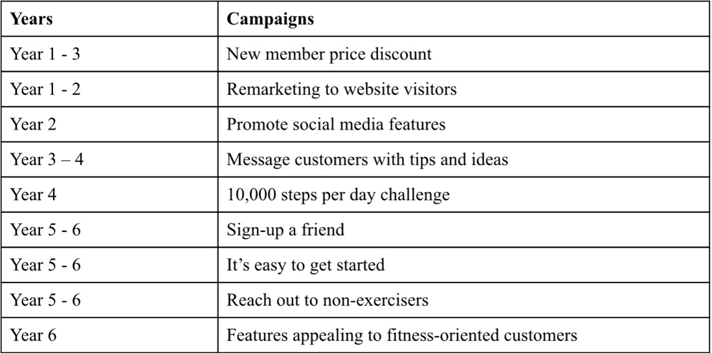

*Table 1: Summary of campaigns ran across six years*

Noting that the two main goals of the simulation case is an average Return on Marketing Investment (ROMI) of 3.0 or higher and a 200% increase in installed base, our group achieved an average ROMI of 2.0 and a 135% increase in installed base (from 2 million in Year 1 to 4.7 million in Year 6) (figures 7 and 8). In our report, we’ll cover the strengths and areas of improvements that we learned from our chosen campaigns.

Customer acquisition refers to gaining new customers (HubSpot, 2023). Key metrics that determine the effectiveness of customer acquisition campaigns include ROMI, number of new customers and revenue (Sutton, M. 2023).

With reference to figures 1 to 6 and table 2, given that Year 6 obtained the most customers for ExerciseMinder, it can be inferred that the combination of ‘**Sign-up a friend**’, ’**It’s easy to get started**’. ‘**Reach out to non-exercisers**’ and ‘**features appealing to fitness-oriented customers**’ campaigns were effective for customer acquisition. Furthermore, these four campaigns contributed to the highest revenue earned and the second highest ROMI across the years (as evident from Figure 7).

‘Sign-up a friend’ focused on giving rebates to users who make referrals. This is attractive to potential customers as it earns them money. Hence, increasing conversions for ExerciseMinder. ‘It’s easy to get started’ and ‘features appealing to fitness-oriented customers’ highlight the features and ease of using the product respectively. This improves acquisition due to relevant content messaging. Regarding ‘reach out to non-exercisers', it taps into a market not directly related to fitness products. When ads for this campaign reaches customers on their favoured platforms, it might facilitate customers’ journey from interest to action, hence increasing installed base. **‘New member price discount’** was also good for acquisition (discussed in question 1e).

Despite the effectiveness of these campaigns for acquisition, it must be acknowledged that none of the campaigns hit ExerciseMinder’s ROMI or installed base goals. To attain these goals, besides revising the budgets, the following strategies could be employed: keyword research to improve search ads and more creative slogans on social media.

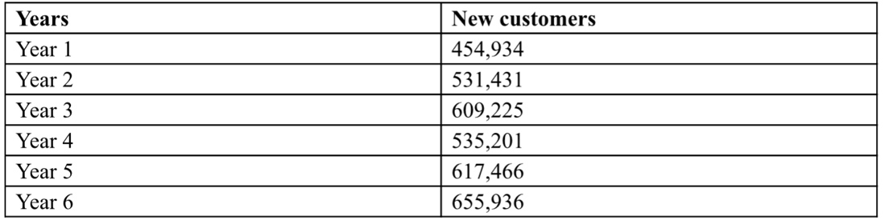

*Table 2: Customer acquisition - new customers*

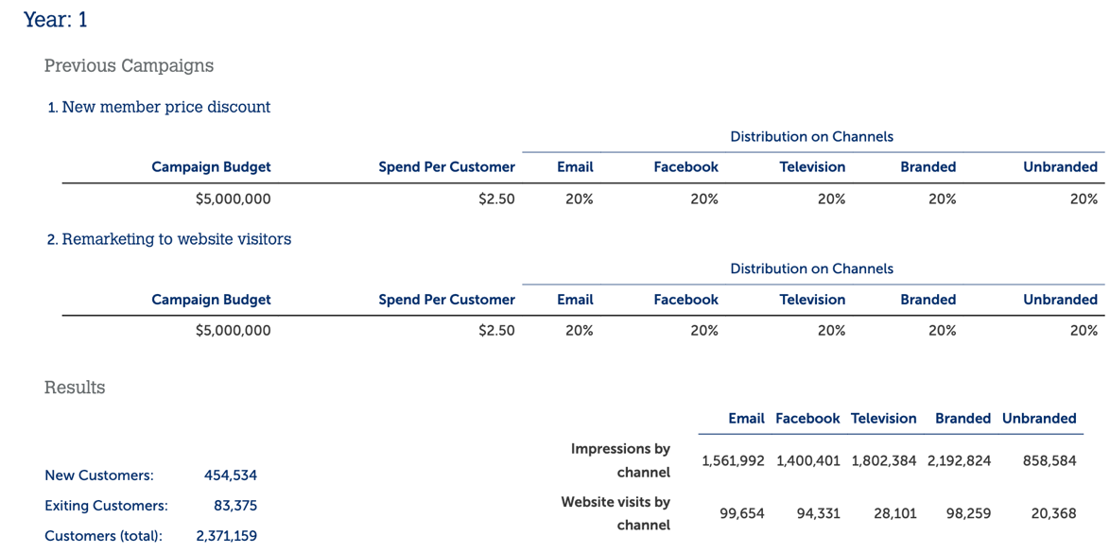

*Figure 1: Year 1 Campaign results*

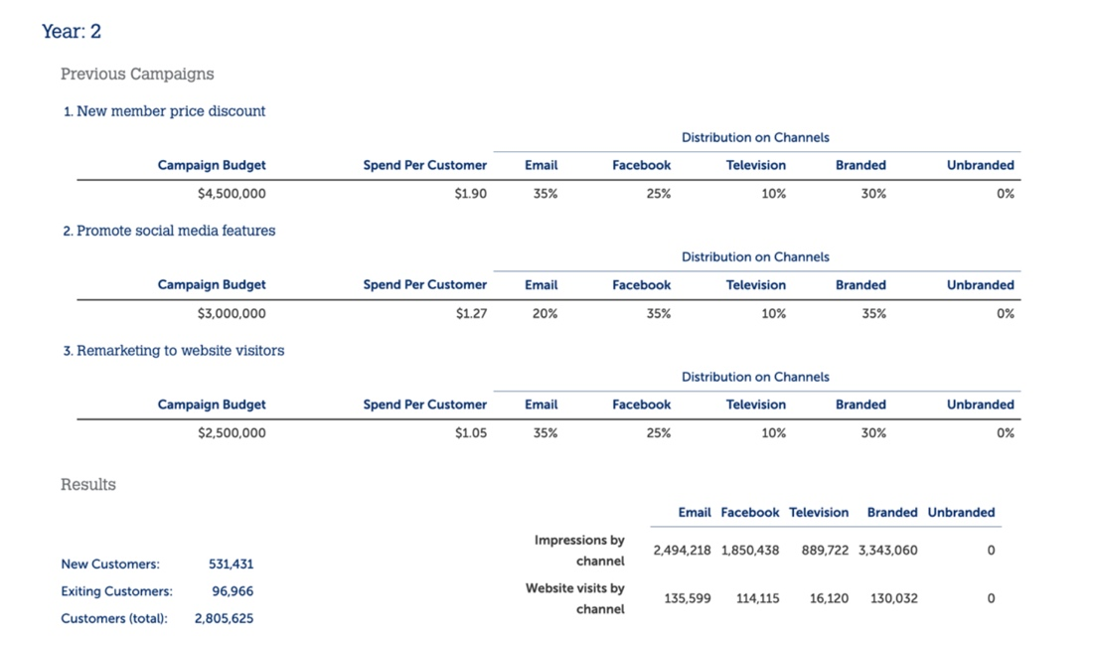

*Figure 2: Year 2 Campaign results*

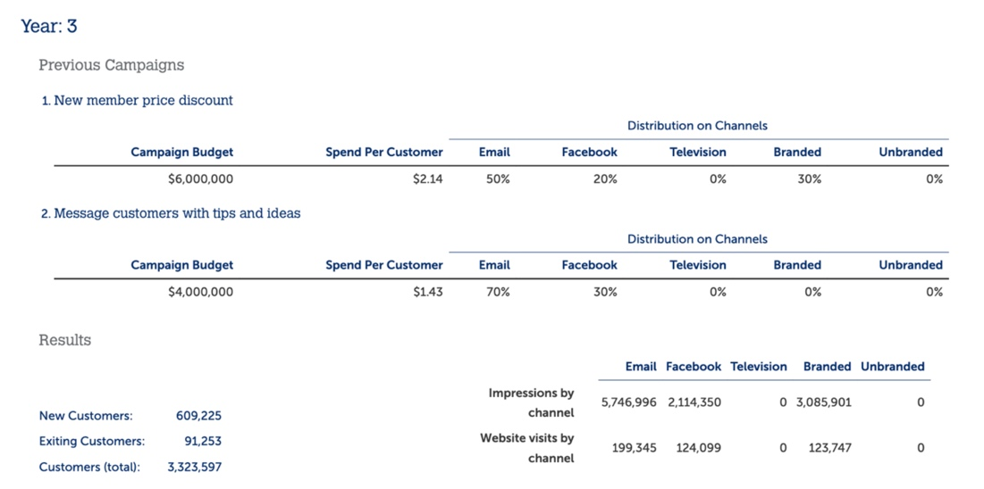

*Figure 3: Year 3 Campaign results*

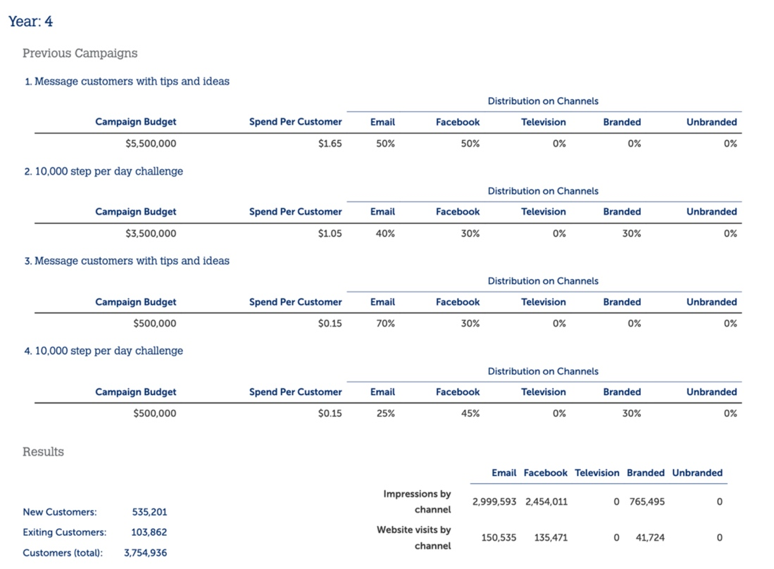

*Figure 4: Year 4 Campaign results*

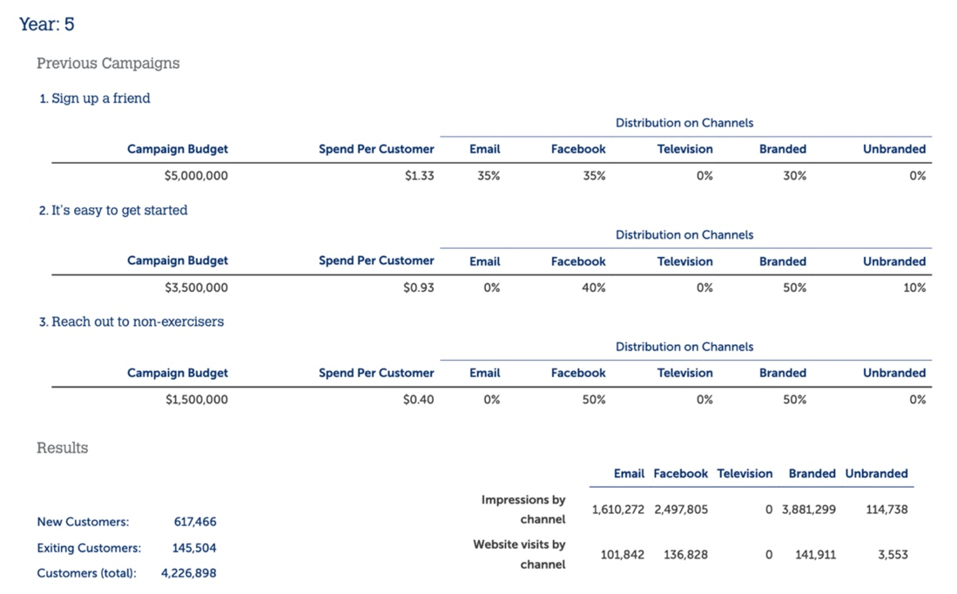

*Figure 5: Year 5 Campaign results*

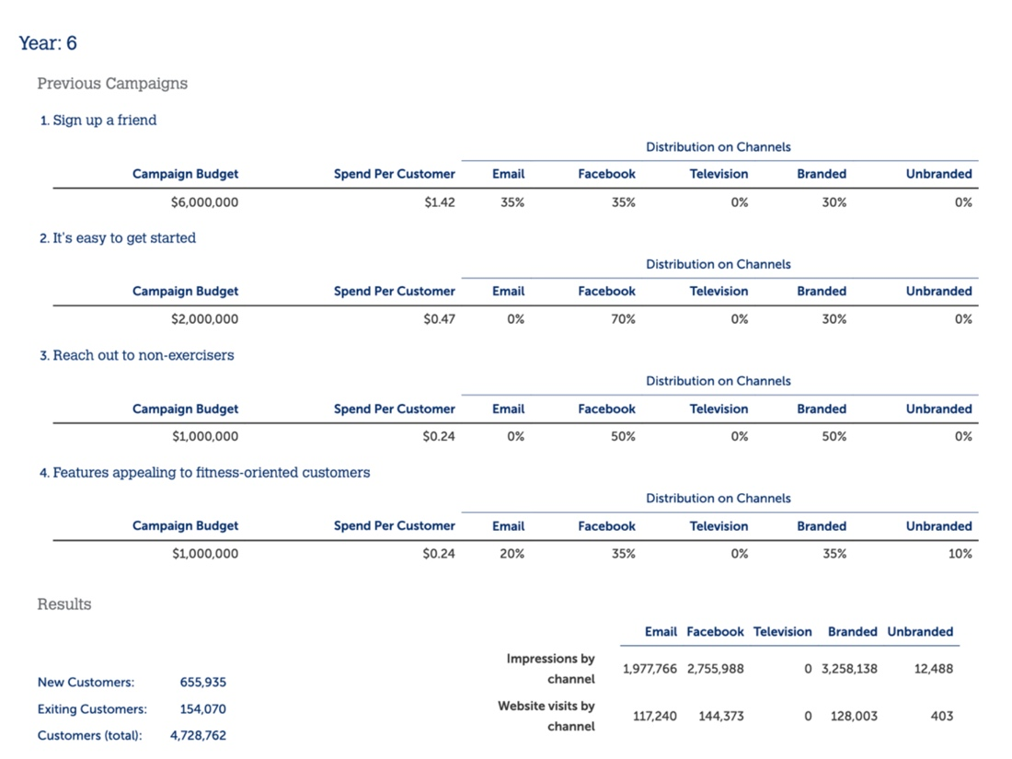

*Figure 6: Year 6 Campaign results*

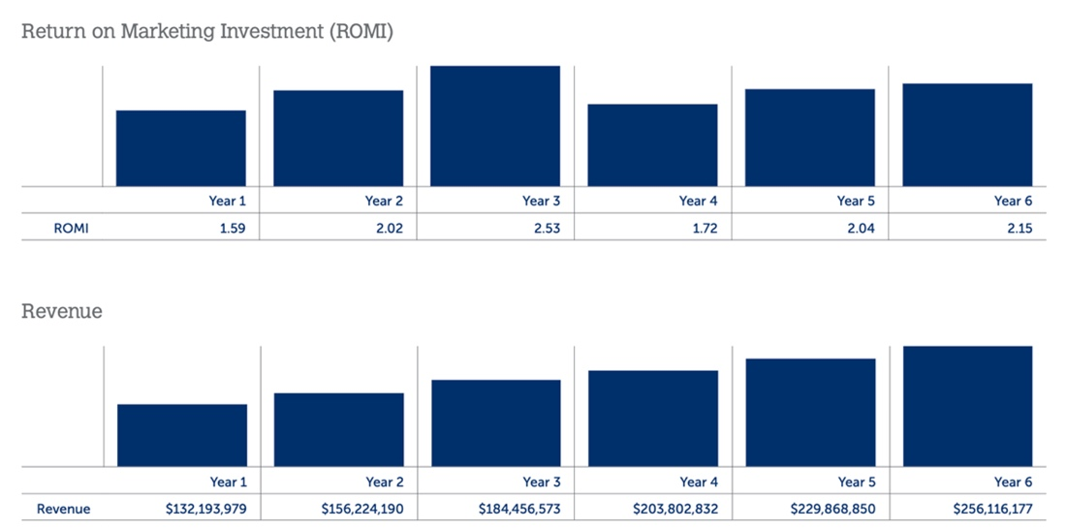

*Figure 7: ROMI (Year-on-Year) results*

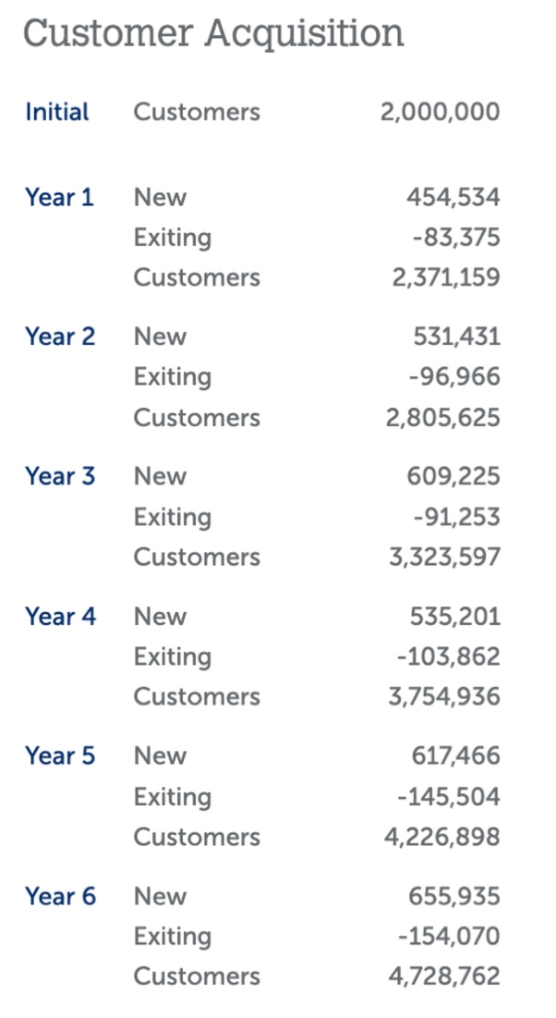

*Figure 8: Customer Base (Year-on-Year)*

**Question 1b**

Customer retention measures the ability of a company to keep its customers over a period of time and maintain customer loyalty. It is indicative of customer satisfaction, repurchasing behaviour and emotional engagements. A high customer retention rate is a key indicator of a successful brand (Olson, 2022).

To calculate the yearly customer retention rate of ExerciseMinder over 6 years, we used this formula:

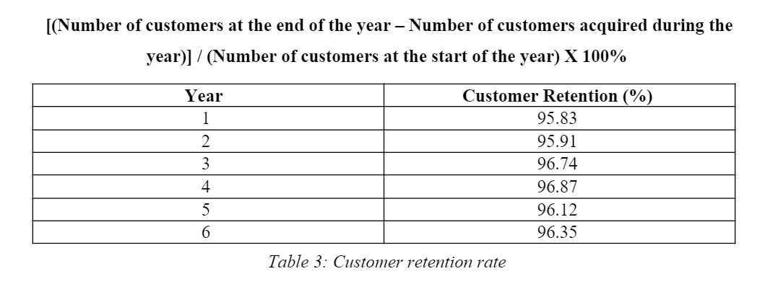Based on Table 3, we noted that the campaigns we used in Table 1have produced consistent customer retention rates of above 95%, with Year 4 standing the highest at 96.87%. The campaigns used in Year 4 were: **Messaging customers with tips and ideas** and **10,000 steps per day challenge.** However, these two campaigns only resulted in a 0.13% increase in customer retention rate in Year 4.

We saw the highest increase in customer retention rate between Year 2 and Year 3 at 0.83% and attributed it to “**Promoting social media features**” campaign. By engaging customers through Facebook Lives and Instagram stories, we believe it creates a positive brand perception, resulting in heightened consumer trust and loyalty.

Between Year 4 and Year 5, our customer retention rate experienced the steepest decrease of 0.75% in the 6-year period. This is likely because the campaigns used in Year 5 were geared towards customer acquisition. Customer retention picked up by 0.23% in Year 6 when we introduced the “**Features appealing to fitness-oriented customers**” campaign.

Overall, while the customer retention rate of ExerciseMinder is relatively consistent, we conclude that the most effective campaigns in the 6-year period are “Promoting social media features” and “Features appealing to fitness-oriented customers”. The high retention rate tells us that ExerciseMinder’s users are committed and motivated by the brand’s effort to create more value in its products, and they enjoy staying connected with the brand. Social media features such as user-generated content and customer reviews are effective in breeding trust and loyalty and enhancing the consumer experience, which in turn increases retention.

**Question 1c)**

Based on Year 1 campaign results, all 5 media channels (Email, Facebook, Branded Search, Unbranded Search and Television) had an equal amount of marketing costs spent and yielded the following results (Figure 9 and Table 4)

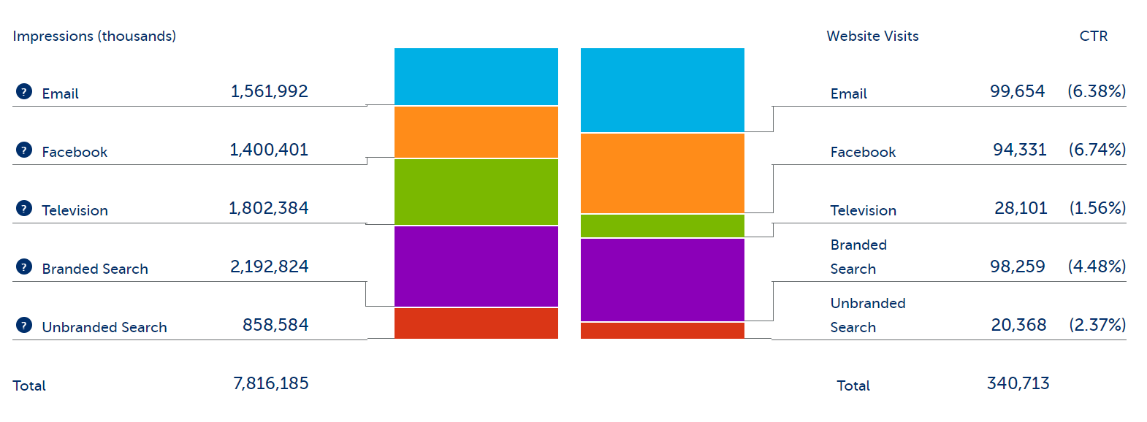  
*Figure 9: Year 1 impressions and CTR*

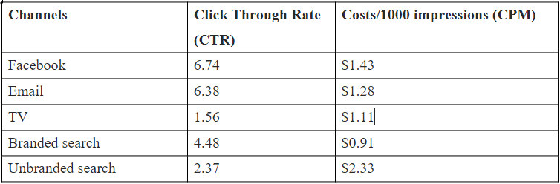  
*Table 4: Year 1 CTR and CPM*

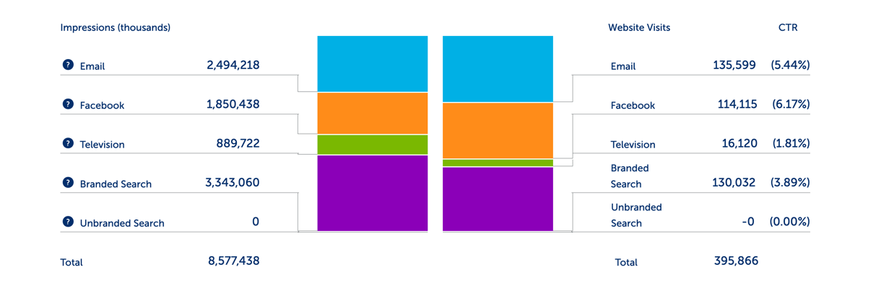

*Figure 10: Year 2 impressions and CTR*

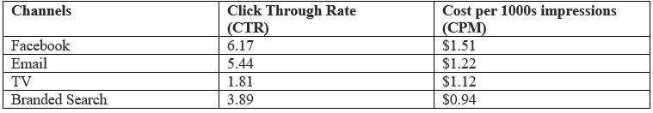  
*Table 5: Year 2 CTR and CPM*

With reference to figure 9, we see the highest impressions on Branded Search, Television and Email, which improves brand awareness. Although Unbranded Search has a good CTR, the cost of marketing investment is high and can impact the returns, resulting in low ROMI. With reference to figures 9 and 10, Branded Search, Email and Facebook garnered the most website visits and highest CTR. When there are more website visitors, it leads to greater traffic and conversions, and a potential increase in installed base.

Comparing Year 1 and Year 2 campaign results, it is possible to conclude that **Facebook, Email, and Branded Search are the most effective channels** to achieve ExerciseMinder‘s main goals due to high CTR, website visits and low average CPM ($1.51+$1.22+$0.94)/3). These three channels were also instrumental for campaigns that were effective for acquisition and retention, highlighted in questions 1a and 1b. Further analysis of media channels will be discussed in question 1e.

**Question 1d)**

We used linear correlation analysis to determine how the media channels affect each other.

R square is a coefficient in correlation analysis with a value between 0 and 1 or 0 and -1.

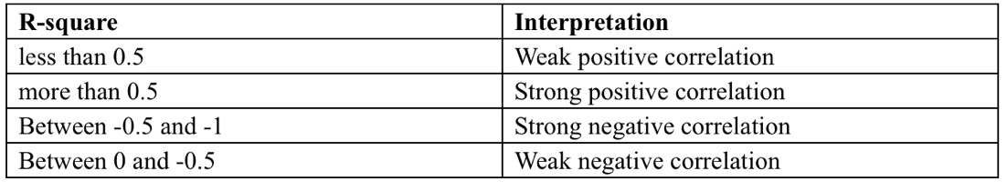

*Table 6: R-square coefficients*

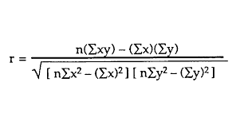

*Figure 11: Correlation Analysis Formula*

Correlation analysis based on the regression analysis data from Year 2 and Year 3 has led us to the following conclusions:

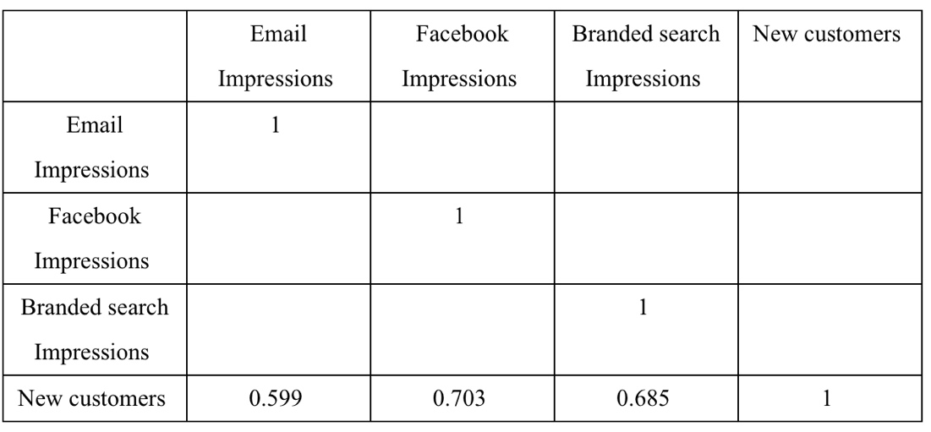

*Table 7: Correlation Analysis – New customers*

For Years 2 and 3, when comparing our three most effective channels’ impressions (Email, Facebook and Branded search) against new customers, it can be concluded that all three impressions are positively correlated with new customers with the correlation coefficients of 0.599, 0.703 and 0.685 (Table 7) respectively. However, the correlation coefficients for Facebook impressions and Branded search impressions are closer to 1 than Email impressions.

Therefore, Email impressions are weakly correlated with new customers, while Facebook impressions and Branded search impressions are strongly correlated with new customers. It can also be deduced that when email, Facebook and Branded search impressions increase respectively, new customers also increase, which increases the installed base.

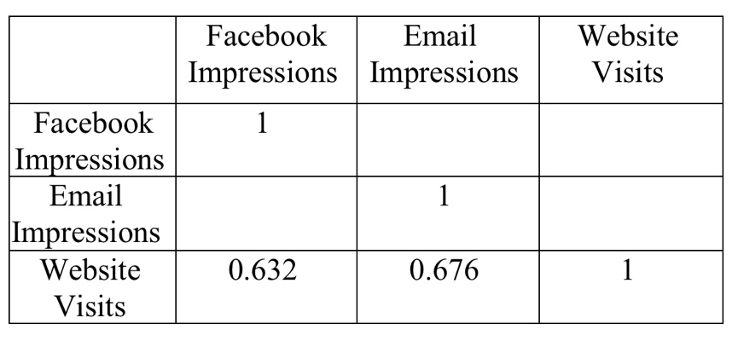

*Table 8: Correlation Analysis – Website visits*

By comparing the correlation coefficients of Facebook and Email impressions against Website Visits, we can see that both Facebook impressions and Email impressions are positively and weakly correlated with website visits, with correlation coefficients of 0.632 and 0.676 (Table 8) respectively, which means that when Facebook impressions increase, website visits will also increase slowly. At the same time, when Email impressions increase, Website visits also tend to increase slowly.

**Question 1e)**

Our intuition led us to conduct multiple A/B tests to determine the amount of budget to allocate per channel. Analytics such as correlation analysis (question 1d) and regression analysis helped us gain and apply insights from the data and its effects on customer acquisition and retention. Our intuition was also challenged - we were already aware of the effectiveness of social media and branded search for conversions and retention; however, we were enlightened by the effectiveness of email.

**How analytics and A/B testing guided our Year 2 campaign decisions:**

We used insights via A/B testing and analysis of data from Year 1 (such CTR and CPM) to find effective channels and campaigns for Year 2.

Facebook, Email, Branded Search, and Television were effective channels because of high CTR and low CPM. Unbranded search was less effective due to high CPM, which would lead to low ROMI (refer to figure 9).

To maximize ROMI, it is critical to consider CTR and CPM when selecting channels for campaign launch.

**Regression analysis:**

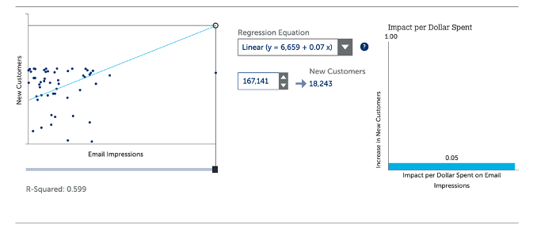

*Figure 12: Email Impressions vs new customers - Year 1*

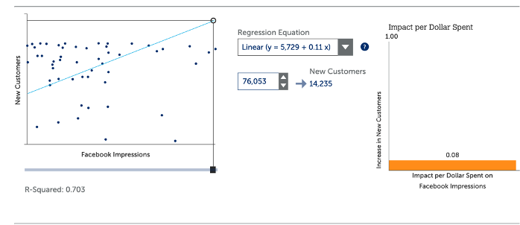

*Figure 13: Facebook Impressions vs new customers – Year 1*

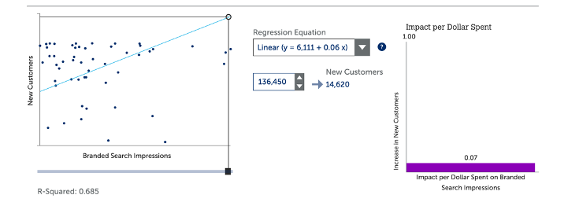*Figure 14: Branded Search Impressions vs new customers – Year 1*

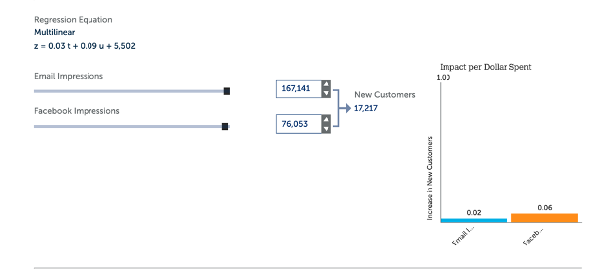

*Figure 15: New customers from Email and Facebook - Year 1*

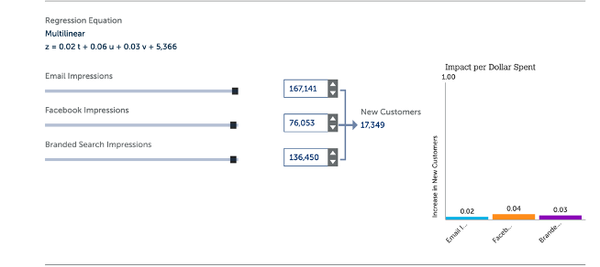

*Figure 16: New customers from Email, Facebook, and Branded Search - Year 1*

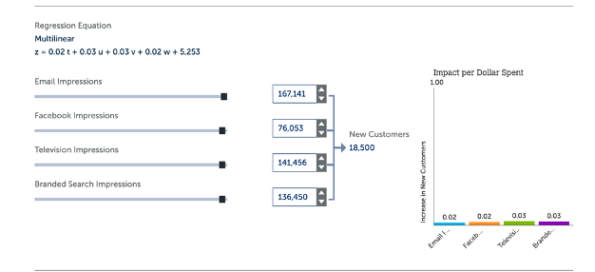

*Figure 17: New customers from Email, Facebook, Television and Branded Search - Year 1*

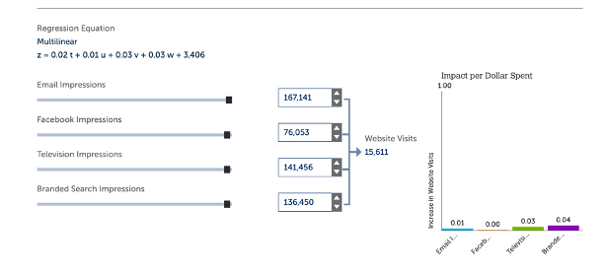

*Figure 18: Website visits from Email, Facebook, Television and Branded Search - Year 1*

**Findings from the regression analysis (figures 12 to 18):**

* Impact per dollar spend for Facebook impressions is 0.08, Branded search impressions at 0.07, Email impressions at 0.05.
* Combination of Email, Facebook, Branded search and Television generates maximum Website visits and new customers.

**A/B testing:**

**Budget:** $200,000

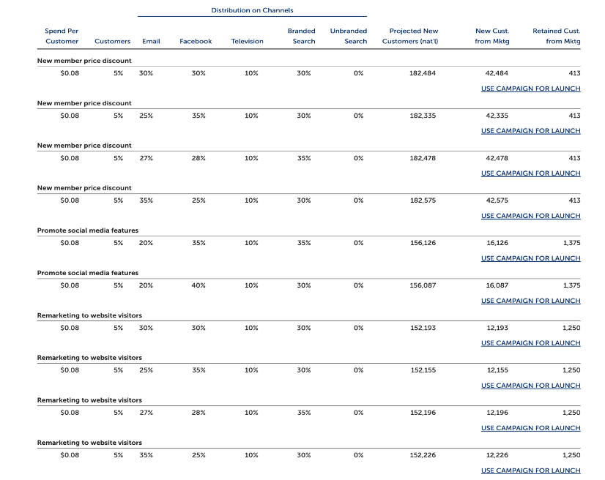*Figure 19: A/B Testing*

**Findings and insights from A/B testing (figure 19):**

For **New customers** – “New member price discount” was effective with the following budget split: Email (35%), Facebook (25%), Branded search (30%), Television (10%).

**Reasons for the above split of budget:**

* Attractiveness of heavily discounted devices attract more customers
* This campaign instils a sense of urgency in potential customers, encouraging action, which can lead to higher installed base.
* Email and Facebook provide targeted content messaging and can drive conversions.
* Brand search captures customers who are already looking for the brand.
* As television has low CTR, we have less budget for that.

For **Retaining customers** – “Promote social media features” was most effective with the following budget split: Facebook (35%), branded search (35%), Email (20%) and Television (10%).

**Reasons for the above split of budget:**

* To retain customers, it's critical to reinforce brand recognition. Branded search helps achieve this goal, while email can provide personalized content to encourage loyalty
* Facebook being a prevalent social media channel - boosts retention.
* Although television can raise brand awareness, it may not be very effective for retention, hence lesser budget

Based on the above insights from Year 1 data, please refer to figure 2 for the three campaigns launched for Year 2. By launching the ‘New member price discount’, ‘promote social media features’ and ‘remarketing to website visitors' campaigns:

* **Installed base increased by 18.3% in Year 2**
* **ROMI increased to 2.02 from 1.59 in Year 2**
* **Average ROMI at the end of 2 years is 1.805**

We’ve attached our regression analysis and A/B testing findings for Year 3 to 6 campaigns in the appendix.

In conclusion, while our overall average ROMI and installed base did not hit ExerciseMinder’s target, it taught us lessons to tweak the budget allocation via A/B testing and analytics.

**Appendix:**

**Year 3**

**Analysis of data from Year 2 (CTR and CPM): To find effective channels for Year 3**

There are 4 channels - Email, Facebook, Branded search, Television.

Based on the previous year’s data, it is possible to conclude that **Facebook, Email and Branded Search are the most effective channels** for launching campaigns due to their high CTR and feasible CPM.

**Regression analysis:**

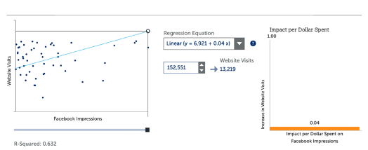*Figure 20: Website visits from Facebook Impressions - Year 2*

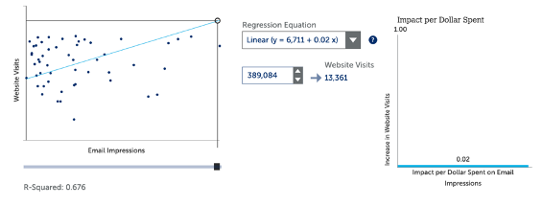 *Figure 21: Website visits from Email Impressions- Year 2*

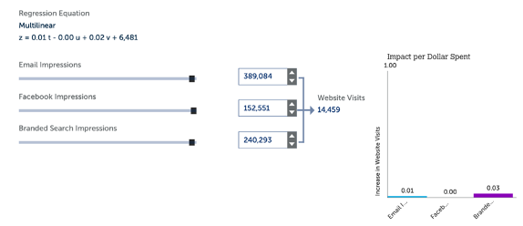

*Figure 22: Website visits from Email, Facebook, and Branded search Impressions - Year 2*

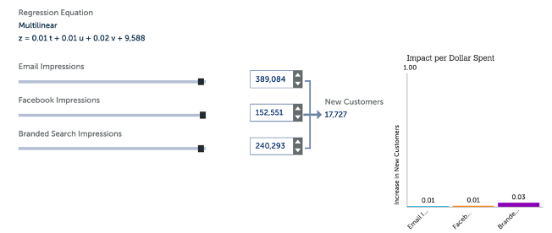

*Figure 23: New customers from Email, Facebook, and Branded search Impressions- Year 2*

**Findings from the regression analysis:**

* Email, Facebook, and Branded search generates maximum Website visits and new customers
* Impact per dollar spent for Facebook impressions is 0.04 followed by email impressions is 0.02.

**A/B testing:**

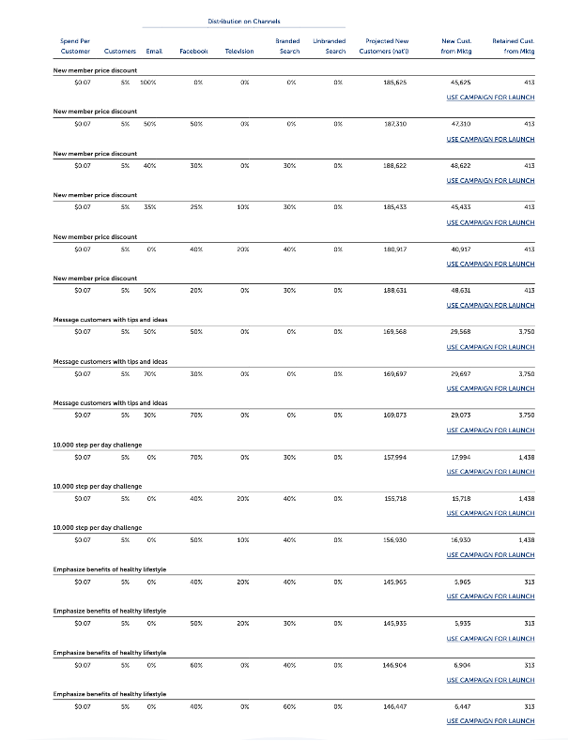*Figure 24: A/B Testing – Year 2*

**Findings from A/B testing:**

* For New customer acquisition - ‘New member price discount’ is the most effective campaign where we have split our budget in the following order: Email (50%), Facebook (20%), branded search (30%).
* For Retaining customers through marketing efforts - ‘Message customers with tips and ideas’ is the most effective campaign where we have split our budget in the following order: Facebook (30%), Email (70%)

Hence from the insights obtained from regression analysis and A/B testing, two campaigns were launched for Year 3 (please refer to figure 3).

By launching the above campaigns,

* **Customer / Installer base increased by 18.45% in Year 3**
* **ROMI increased to 2.53 from 2.02 in Year 3**
* **Average ROMI at the end of 3 year is 2.57**

Similarly, from year 4 onwards, we repeat the same steps followed for the previous years to find the most effective channels and campaigns.

**Year 4**

**A/B testing:**

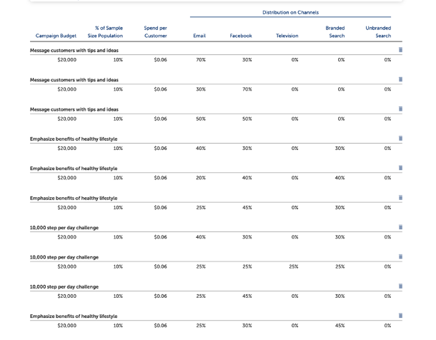*Figure 25: A/B Testing*

Please refer to figure 4 for Year 4 campaigns that were launched.

By launching the above campaigns,

* **Customer / Installer base increased by 12.97% in Year 4**
* **ROMI decreased to 1.72 from 2.53 in Year**
* **Average ROMI at the end of 4 year 1.96**

**Year 5**

**A/B testing:**

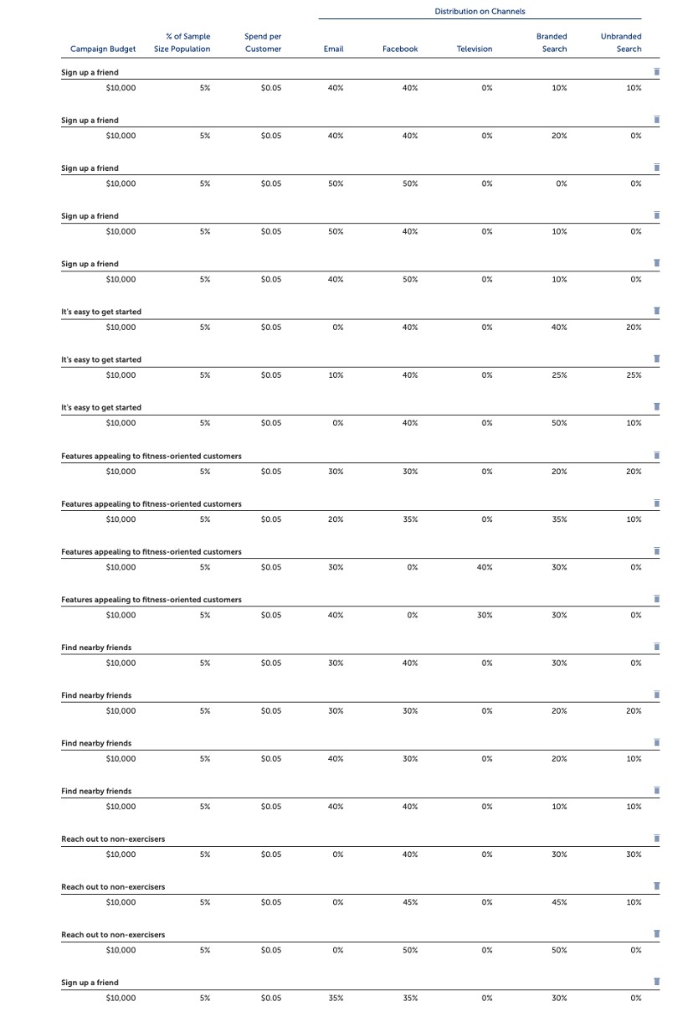

*Figure 26: A/B Testing*

Please refer to figure 5 for Year 5 campaigns that were launched.

By launching the above campaigns,

* **Customer / Installer base increased by 12.56 % in Year 5**
* **ROMI increased to 2.04 from 1.72 in Year 5**
* **Average ROMI at the end of 5 year 1.98**

**Year 6**

**A/B testing**

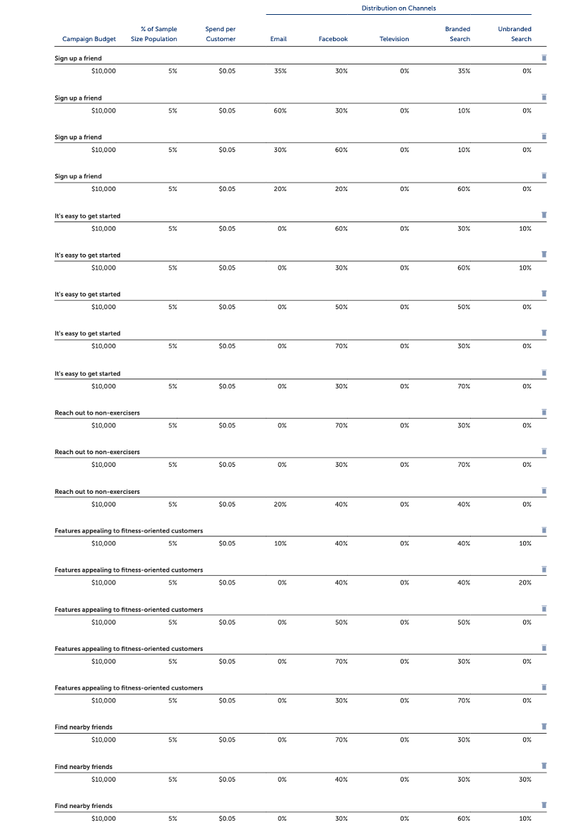*Figure 27: A/B Testing*

Please refer to figure 6 for Year 6 campaigns that were launched.

By launching the campaigns,

* **Customer / Installer base increased by 11.87% in Year 6**
* **ROMI increased to 2.15 from 2.04 in Year 6**
* **Average ROMI at the end of 6 year 2.0**

**References:**

# HubSpot. (2023). *The Ultimate Guide to Customer Acquisition for 2023*. Retrieved from: <https://blog.hubspot.com/service/customer-acquisition>

Olson, S. (2022, September 16). *What is customer retention? 11 examples and strategies to retain customers.* Retrieved from: <https://www.zendesk.com/sg/blog/customer-retention/>

# Sutton, M. (2023, March 23). *What Is Customer Acquisition? A Complete 2023 Guide.* Retrieved from: <https://www.shopify.com/blog/customer-acquisition>